WEEK 2 Assignments Queries and Results

/*==========================================================
1. EXPLORE THE DATABASE
==========================================================*/
1. Display All Tables
SHOW TABLES;
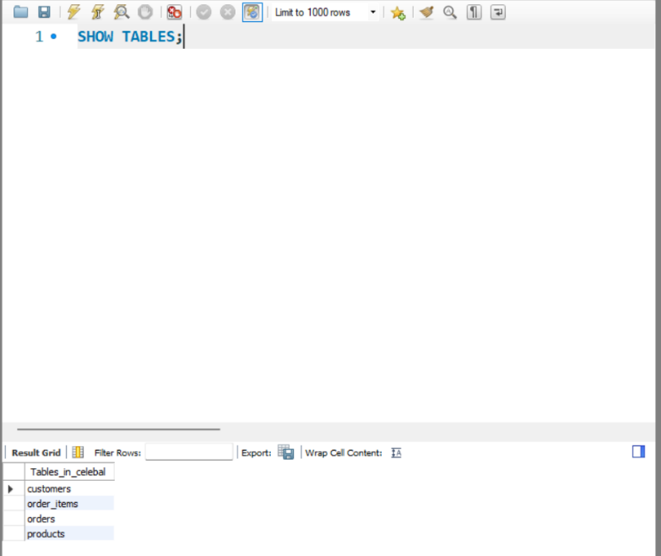

2.Display Structure of Products Table
DESC products;
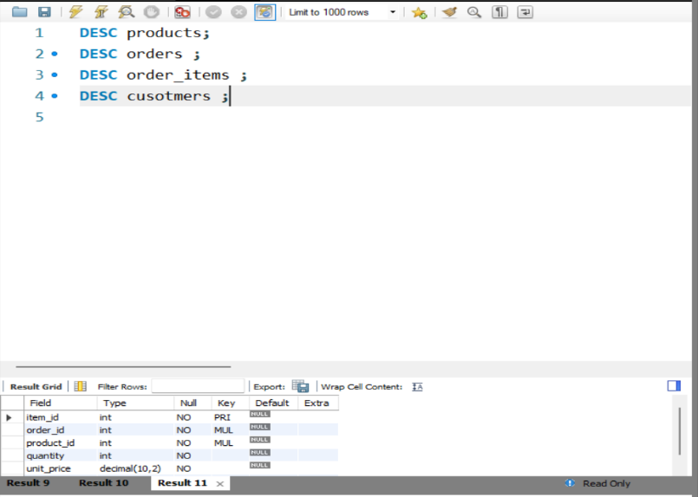

3.Display Customer Data and Product Records
SELECT *
FROM customers;
SELECT * FROM products;
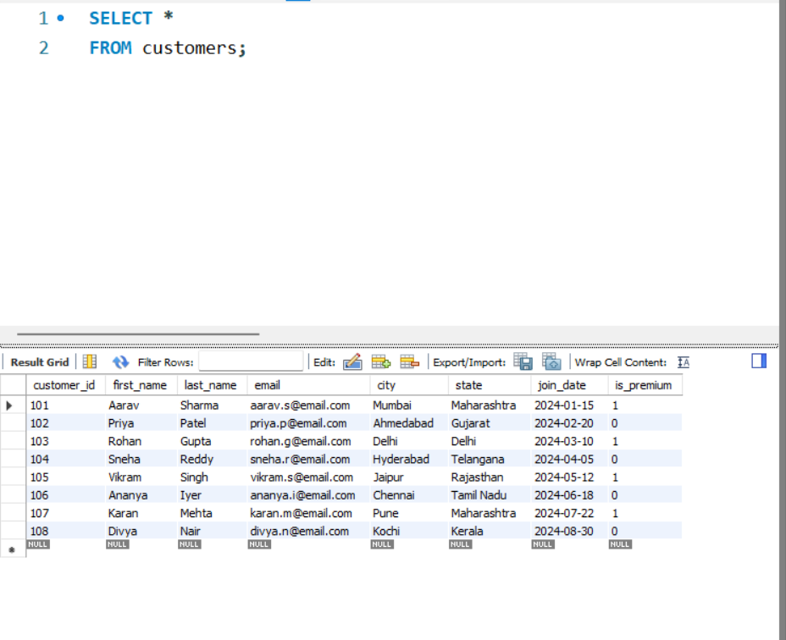

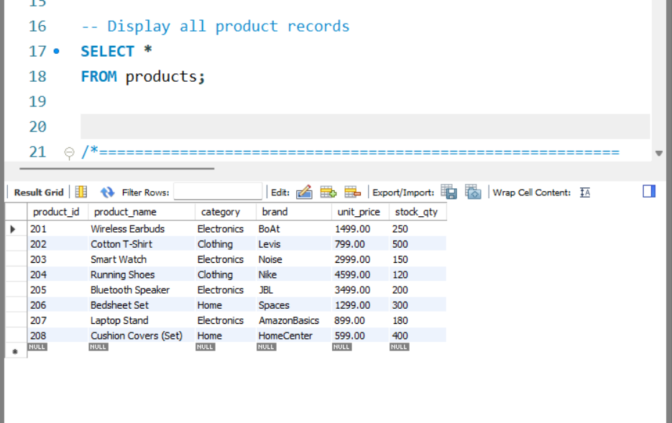

/*==========================================================
2. FILTERING USING WHERE CLAUSE
==========================================================*/
4. Retrieve all delivered orders
SELECT *
FROM orders
WHERE status = 'Delivered';
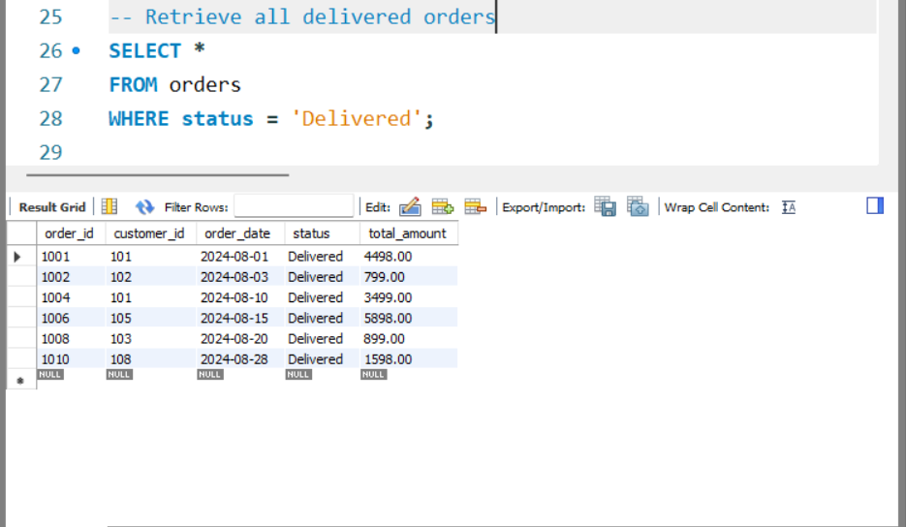

5. Retrieve Electronics products costing more than ₹2000
SELECT *
FROM products
WHERE category = 'Electronics'
AND unit_price > 2000;

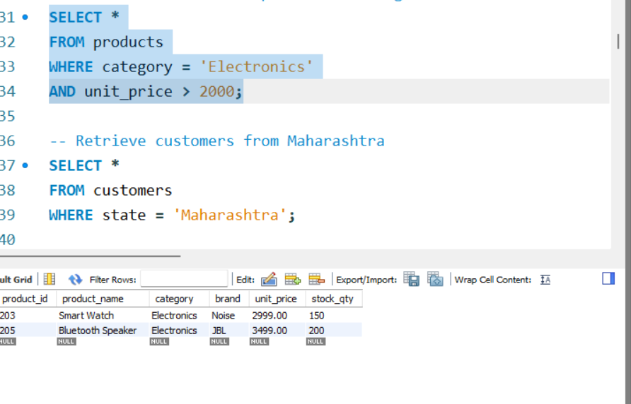
6. Retrieve customers from Maharashtra
SELECT *
FROM customers
WHERE state = 'Maharashtra';
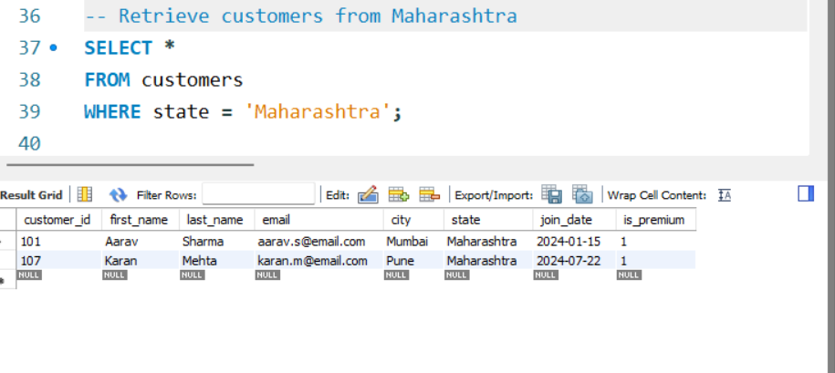
/*==========================================================
3. AGGREGATION FUNCTIONS
==========================================================*/
7. Calculate total revenue from delivered orders
SELECT
SUM(total_amount) AS Total_Revenue
FROM orders
WHERE status = 'Delivered';
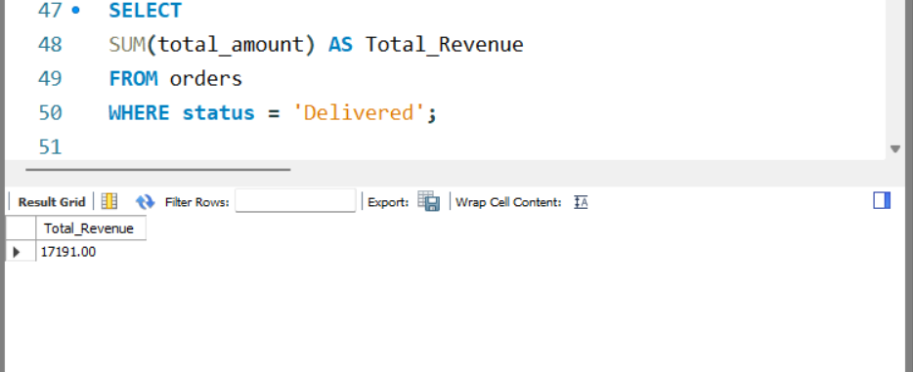

8. Calculate average product price by category
SELECT
category,
AVG(unit_price) AS Average_Price
FROM products
GROUP BY category;
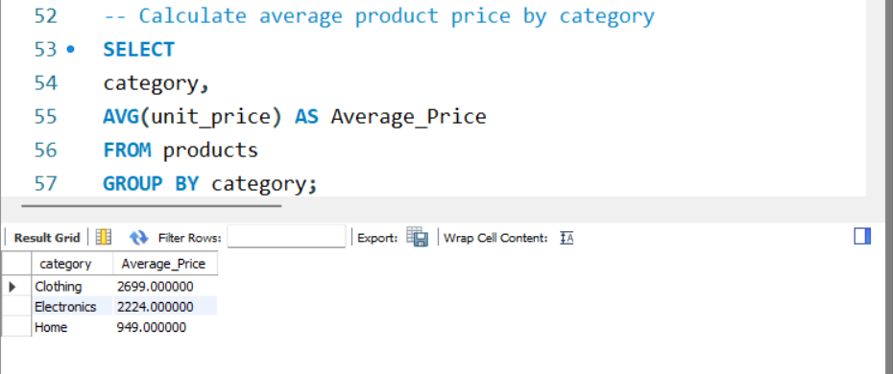

9. Count orders and revenue by order status
SELECT
status,
COUNT(*) AS Total_Orders,
SUM(total_amount) AS Revenue
FROM orders
GROUP BY status
ORDER BY Revenue DESC;
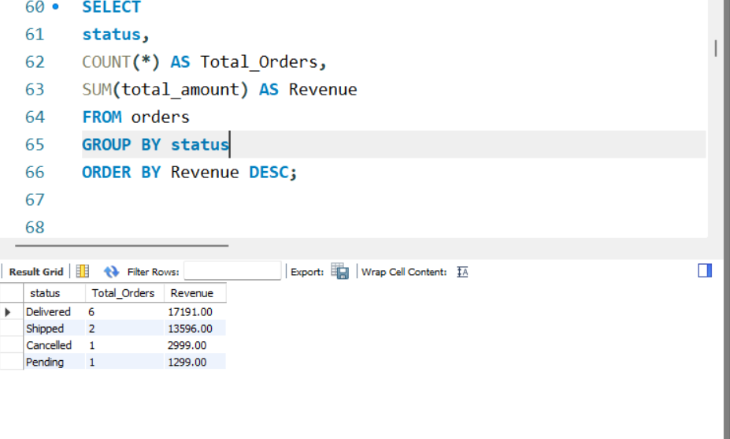
/*==========================================================
4. SORTING & LIMIT
==========================================================*/
10. Display Top 5 most expensive products
SELECT *
FROM products
ORDER BY unit_price DESC
LIMIT 5;
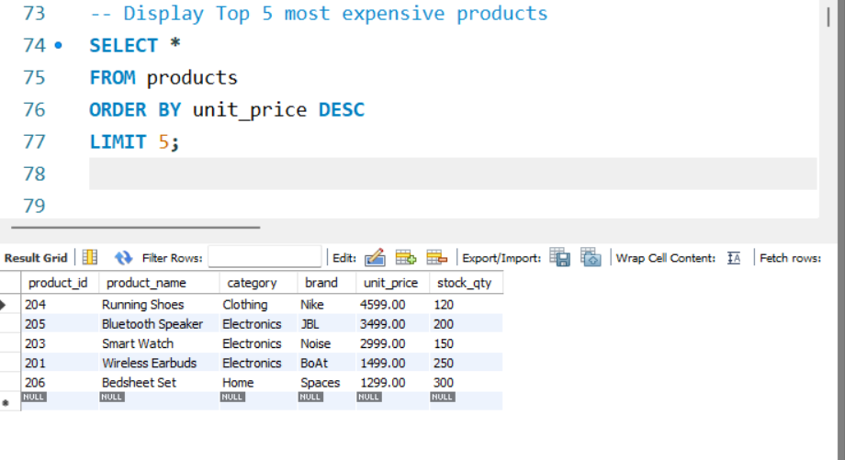
/*==========================================================
5. BUSINESS ANALYSIS USING JOINS
==========================================================*/
11. Find top customers based on total spending
SELECT
c.customer_id,
CONCAT(c.first_name,' ',c.last_name) AS Customer_Name,
SUM(o.total_amount) AS Total_Spent
FROM customers c
JOIN orders o
ON c.customer_id = o.customer_id
GROUP BY c.customer_id, Customer_Name
ORDER BY Total_Spent DESC;

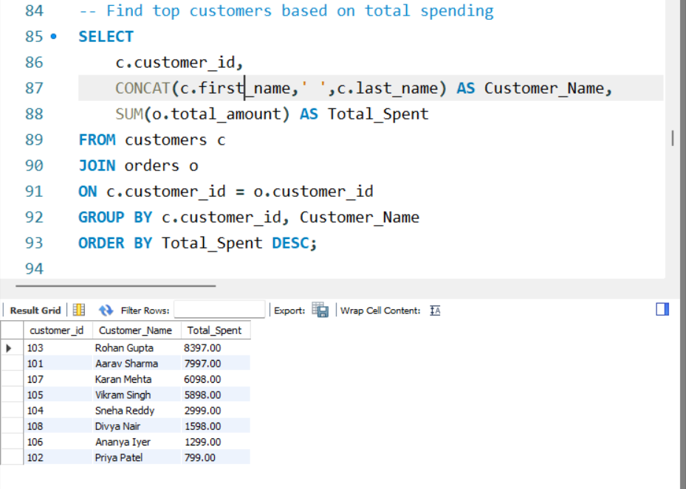

12. Find best-selling products based on quantity sold
SELECT
p.product_name,
SUM(oi.quantity) AS Quantity_Sold
FROM products p
JOIN order_items oi
ON p.product_id = oi.product_id
GROUP BY p.product_name
ORDER BY Quantity_Sold DESC;

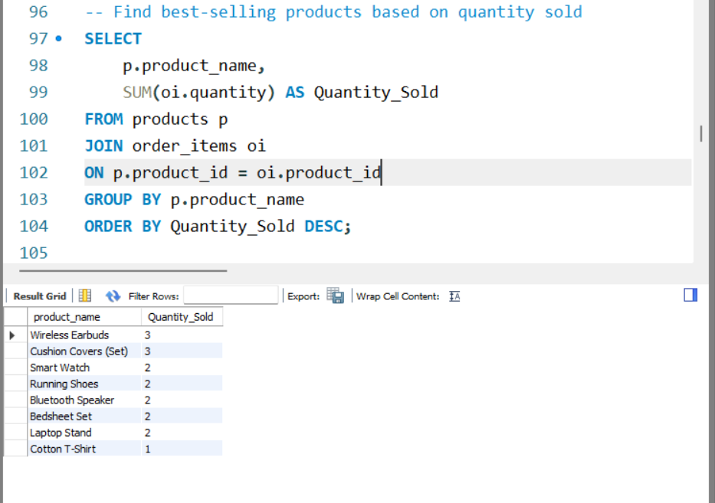
13. Calculate revenue generated by each product category
SELECT
p.category,
SUM(oi.quantity * oi.unit_price) AS Revenue
FROM products p
JOIN order_items oi
ON p.product_id = oi.product_id
GROUP BY p.category
ORDER BY Revenue DESC;
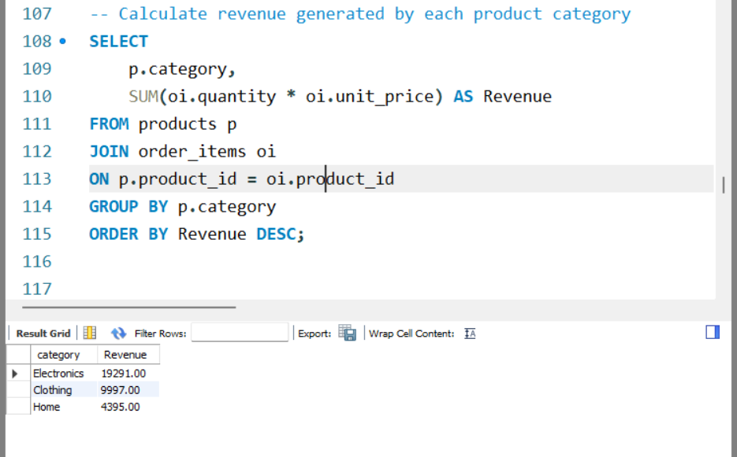

/*==========================================================
6. DATA VALIDATION
==========================================================*/
14. Verify total number of records in each table
SELECT
(SELECT COUNT(*) FROM customers) AS Customers,
(SELECT COUNT(*) FROM products) AS Products,
(SELECT COUNT(*) FROM orders) AS Orders,
(SELECT COUNT(*) FROM order_items) AS Order_Items;
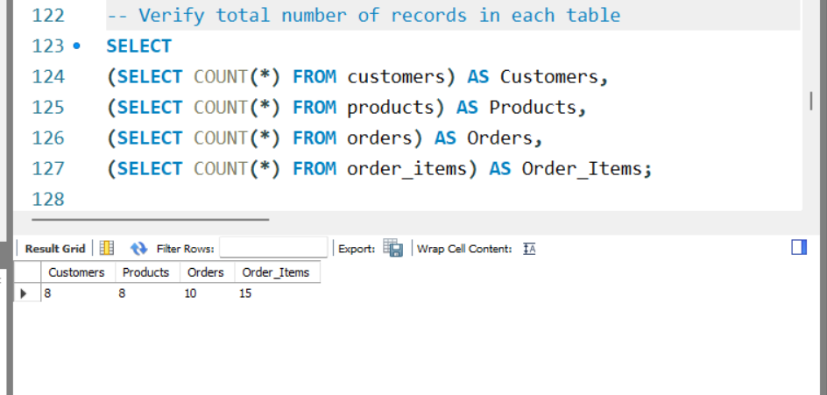

/*==========================================================
7. CHECK FOR DUPLICATE EMAILS
==========================================================*/
SELECT
email,
COUNT(*) AS Duplicate_Count
FROM customers
GROUP BY email
HAVING COUNT(*) > 1;
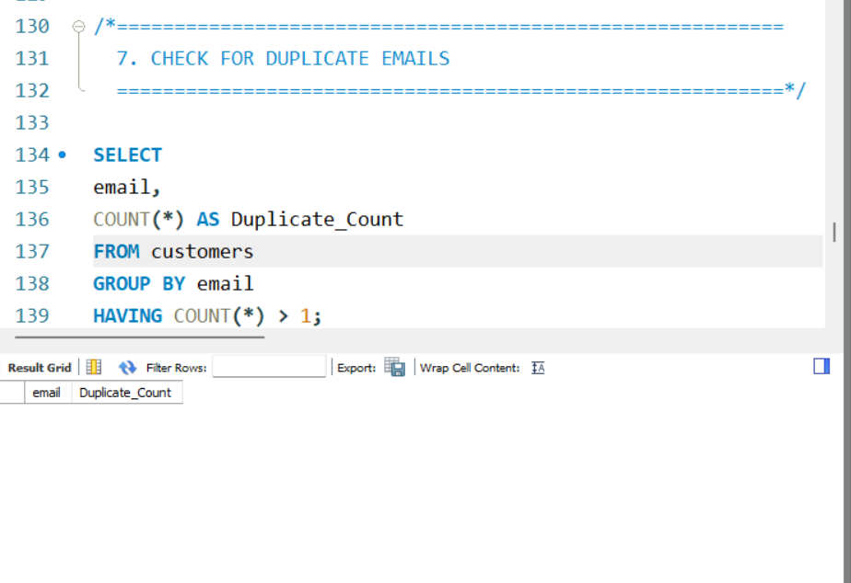

/*==========================================================
8. CHECK FOR INVALID PRODUCT PRICES
==========================================================*/
SELECT *
FROM products
WHERE unit_price <= 0;
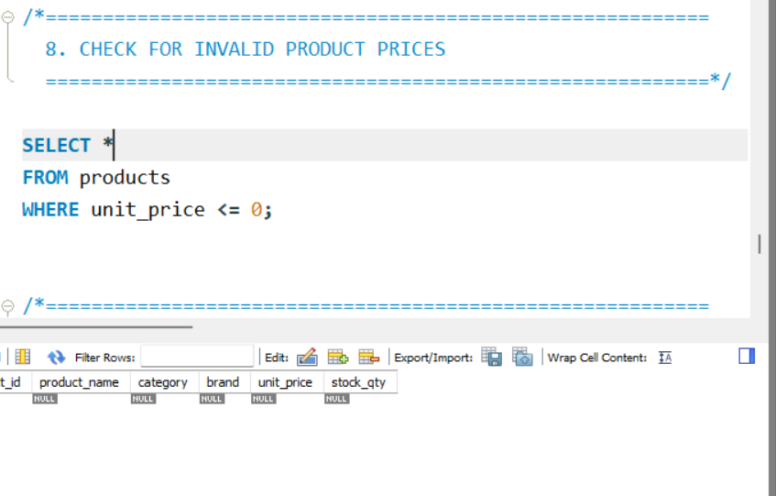
/*==========================================================
9. COMPLETE ORDER DETAILS USING MULTIPLE JOINS
==========================================================*/
SELECT
o.order_id,
o.order_date,
CONCAT(c.first_name,' ',c.last_name) AS Customer_Name,
p.product_name,
oi.quantity,
oi.unit_price,
oi.discount_pct
FROM orders o
JOIN customers c
ON o.customer_id = c.customer_id
JOIN order_items oi
ON o.order_id = oi.order_id
JOIN products p
ON oi.product_id = p.product_id
ORDER BY o.order_id;

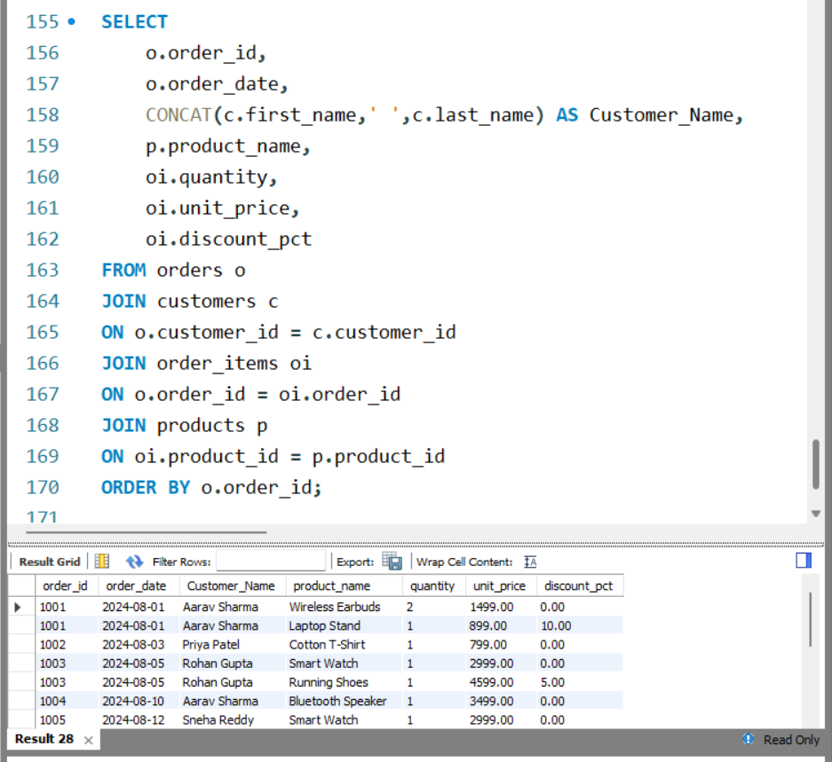

1. Database Exploration
What We Did
Explored the database to verify that all required tables were created successfully. Examined the table structures and confirmed that the customer, product, order, and order item data had been loaded correctly.
Insight
The database consists of four related tables (customers, products, orders, and order_items) that together store customer information, product details, order records, and purchased items. The data was loaded successfully and is ready for analysis.

2. Data Filtering
What We Did
Applied different filtering conditions to retrieve specific records, such as delivered orders, premium products, and customers from a particular state.
Insight
Filtering allows businesses to focus on specific subsets of data, making it easier to analyze customer behavior, product performance, and order status efficiently.

3. Data Aggregation
What We Did
Performed calculations to determine total revenue, average product prices, and the number of orders for different order statuses.
Insight
Aggregation provides summarized information that helps measure business performance. It enables quick identification of revenue trends and comparisons across different product categories and order statuses.

4. Sorting and Ranking
What We Did
Sorted the data to identify the highest-priced products and rank customers based on their total spending.
Insight
Sorting helps identify top-performing products and valuable customers, allowing businesses to make informed decisions regarding marketing, inventory, and customer loyalty programs.

5. Business Analysis
What We Did
Combined multiple tables using JOIN operations to analyze customer purchases, product sales, and revenue generated by different product categories.
Insight
Business analysis provides meaningful insights into customer purchasing patterns and product performance. It helps identify popular products, high-value customers, and profitable product categories.

6. Data Validation
What We Did
Validated the database by checking the number of records, identifying duplicate values, and verifying that invalid data such as negative prices was not present.
Insight
Data validation ensures the accuracy and reliability of the database. Maintaining clean and consistent data is essential for generating correct reports and making informed business decisions.

Overall Conclusion
What We Did
Successfully explored, filtered, aggregated, sorted, and analyzed the e-commerce sales data using SQL. The database was validated to ensure data integrity, and business-oriented insights were generated using SQL queries.
Final Insight
The analysis shows that completed (delivered) orders contribute the majority of the company's revenue. Product and customer analysis helps identify top-performing categories and valuable customers, while data validation confirms that the database is accurate and reliable. These insights can support better decision-making in areas such as sales strategy, inventory management, and customer relationship management.

